4.1 Fundamentals of SQLite
4.1.1 What is SQLite?
SQLite is like carrying a mini-database in your backpack. No internet or server needed — just unzip it and use!
- SQLite is a lightweight, open-source, embedded database system.
- Unlike MySQL, Oracle, or PostgreSQL, it does not require a separate server.
- Data is stored in a single file (e.g., mydb.sqlite or mydb.db).
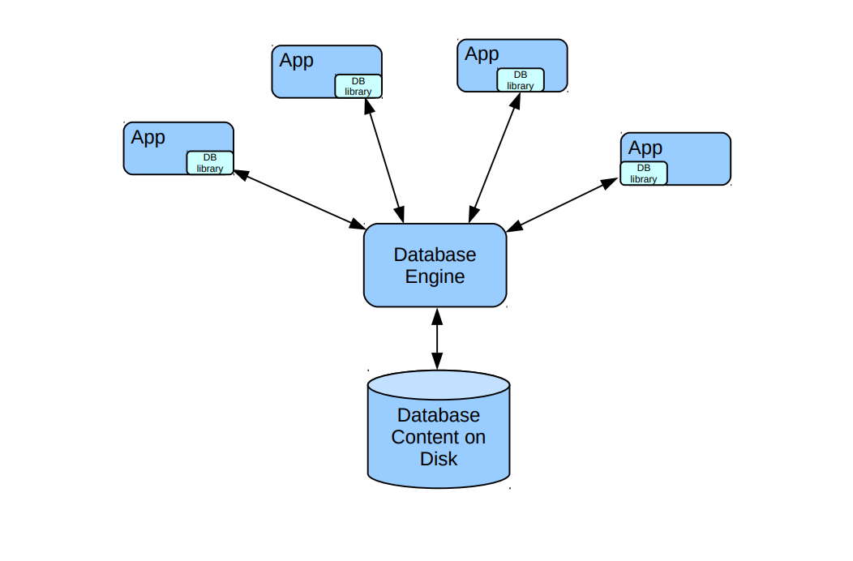
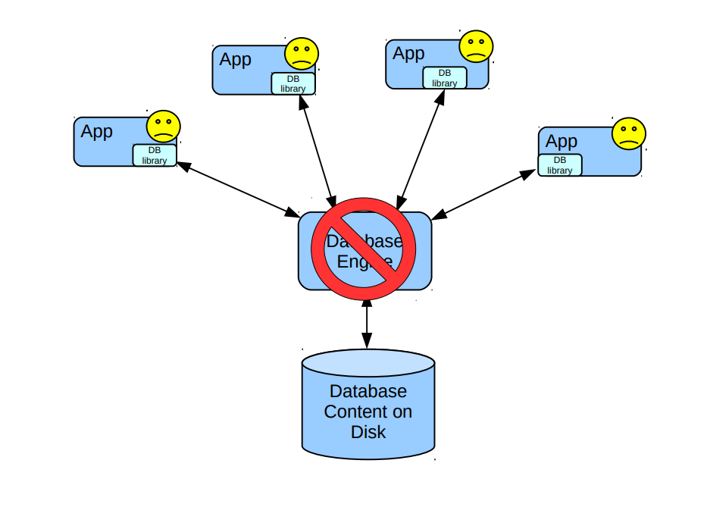
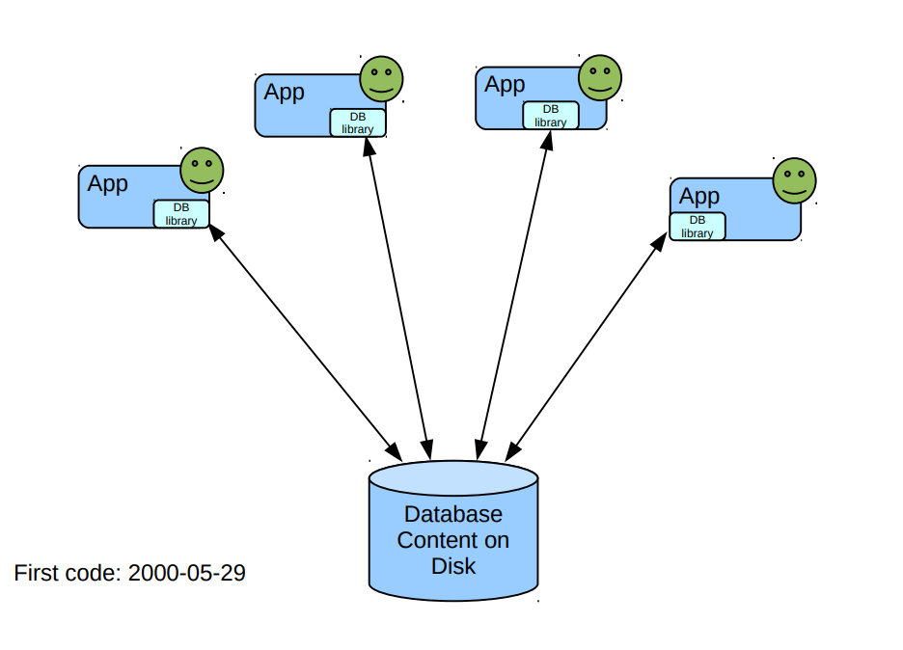

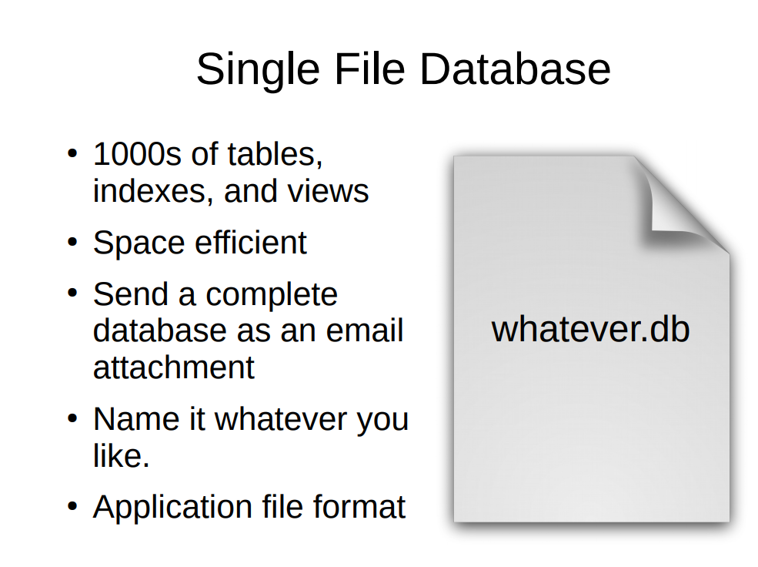

Key Features of SQLite
Serverless | no separate process, database runs directly in applications.
Zero-configuration | no installation or setup needed
Cross-platform | works on Windows, Linux, macOS, Android, iOS.
Single file storage | all data in one .db or .sqlite file.
Lightweight & Fast | small size, suitable for mobile and embedded systems.
Open-source | free to use, included in Python by default
Transactional | supports ACID (Atomicity, Consistency, Isolation, Durability).

Use-Cases of SQLite
Mobile apps (Android, iOS) | store local user data.
Web browsers (Chrome, Firefox) | manage history & cache.
IoT devices | lightweight storage.
Desktop applications | small/medium datasets.
Prototyping | quick testing before deploying on full RDBMS.

4.1.2 SQLite Data Types
SQLite uses dynamic typing → a column can store any type of value (not strict).
However, it provides five primary data types:
- NULL
  - Means no value, empty, or unknown.
  - Imagine a student hasn’t given their email yet.
  - We keep the place empty using NULL.
Example :
INSERT INTO Students (id, name, age, email)
VALUES (1, 'Amit', 20, NULL);

- INTEGER
  - Stores whole numbers (1, 2, -5, 1000).
  - Example: Age, Roll Number, IDs.
Example :
INSERT INTO Students (id, name, age)
VALUES (2, 'Herry', 21);

- REAL
  - Stores floating-point numbers (3.14, 25.6).
  - Example: Salary, Price.
Example :
INSERT INTO Products (id, name, price)
VALUES (101, 'Laptop', 45000.75);

- TEXT
  - Stores string values (names, addresses, messages).
  - Example: "Python", "Hello".
Example :
INSERT INTO Students (id, name, age)
VALUES (3, 'Suresh', 22);

- BLOB (Binary Large Object)
  - Stores binary data (images, audio, files).
  - Example: Storing profile pictures in database.
Example :
INSERT INTO Files (id, file_data)
VALUES (1, X'FFD8FFE000104A464946');

Example Table: students
CREATE TABLE students (
id INTEGER PRIMARY KEY,
name TEXT NOT NULL,
age INTEGER,
gpa REAL,
photo BLOB
);

Column | Data Type | Description
id | INTEGER | Unique ID for each student
name | TEXT | Student's full name
age | INTEGER | Their age
gpa | REAL | Grade Point Average
photo | BLOB | Picture stored in binary form

📘 Data Type Examples in Practice

INSERT INTO students (id, name, age, gpa)
VALUES (1, 'Alice', 20, 3.8);

- 1 → INTEGER
- 'Alice' → TEXT
- 20 → INTEGER
- 3.8 → REAL

importing sqlite3 module
- Sqlite3 module can be imported into Python.
- The SQLite database can be accessed from Python language.
- Database as well as tables can be created from python program.
- Insert, Update, Delete, Select all these operations with this database can also be allowed through python program.
- To import sqlite3 module, write following:
  - import sqlite3
- It imports the sqlite3 module into python which allows all variables as well as
functions of sqlite3 module to be accessed from python program.

connect() method
To establish connection with sqlite database, connect() method is used.
If database is not available then it creates new database with given name.
Using connect() method, connection object is created
Syntax:
Var_name=sqlite3.connect('database_name')
Example
import sqlite3
conn=sqlite3.connect('emp.db')
print("Successfully connected")
print(conn)

Output :
Successfully connected
<sqlite3.Connection object at 0x0406CA20>

Python finds the emp.db database, then it opens the existing database and if it is not found then it creates new database.

cursor() method
Python allows sqlite3.cursor class.
This class allows to perform different operations within SQLite database.
It allows multiple methods to execute SQLite statements.
Cursor object is created using cursor() method.
Syntax:
Connection_name.cursor()
Example:
conn.cursor()
It allows following methods:
• execute()
o fetchone()
o fetchall()
If user doesn't create cursor object, the python automatically creates cursor implicitly.
o A=curs.execute() #explicitly cursor is created
o B=conn.execute() #automatically cursor is created

execute() method
To execute the SQL statements means operations like INSERT, UPDATE, DELETE etc., execute() method of cursor object is used.
Syntax:
• Explicitly cursor is created:
Var_name=cursor_name.execute("SQL_statement")
o Automatically cursor is created: Var_name=connection_name.execute("SQL_statement")

fetchone() method
- fetchone() method extract one record from current position.
- First time it extracts first record. If again it is executed then it extracts second record.
- If not a single record exists or after the last record, it is executed then it returns "None".
- It generates one dimensional array.
Example
import sqlite3
conn=sqlite3.connect('emp.db')
a=conn.execute("select * from tblemp") #automatically cursor object is created.
b=a.fetchone()
print(b)
print("Emp id:",b[0])
print("Emp. name:",b[1])
print("Emp. gender:",b[2])
print("Emp. join date:", b[3])
print("Emp. salary:", b[4])
print(a.fetchone())

Output:
(3, 'Geeta', 'F', '2010-08-20', 25000)
Emp id: 3
Emp. name: Geeta
Emp. gender: F
Emp. join date: 2010-08-20
Emp. salary: 25000 (4, 'Jatin', 'M', '2011-04-12', 25000)

fetchall() method
fetchall() method is used to extract all records based on given query.
It generates two dimensional array.
Example

import sqlite3
conn=sqlite3.connect('emp.db')
a=conn.execute("select * from tblemp") #automatically cursor object is created.
b=a.fetchall()
print(b)

print("Emp id:",b[0][0])
print("Emp. name:",b[0][1])
print("Emp. gender:",b[0][2])
print("Emp. join date:", b[0][3])
print("Emp. salary:", b[0][4],"\n")

print("Emp id:",b[1][0])
print("Emp. name:",b[1][1])
print("Emp. gender:",b[1][2])
print("Emp. join date:", b[1][3])
print("Emp. salary:", b[1][4],"\n"

Output: [(3, 'Geeta', 'F', '2010-08-20', 25000), (4, 'Jatin', 'M', '2011-04-12', 25000), (5, 'Prashant', 'M', '2009-07-10', 25000)]
Emp id: 3
Emp. name: Geeta
Emp. gender: F
Emp. join date: 2010-08-20
Emp. salary: 25000
Emp id: 4
Emp. name: Jatin
Emp. gender: M
Emp. join date: 2011-04-12
Emp. salary: 25000

#step 1 import library
import sqlite3
#step 2 connection and create db
con = sqlite3.connect('test.db')
#step 3 connection with cursor
cursor = con.cursor()
#----------------------Create Table------------------------------
student = """Create table Student
(id INTEGER PRIMARY KEY ,
StudentName TEXT NOT NULL,
Class Text)"""
cursor.execute(student)
con.commit()
con.close()
#----------------------Insert Data------------------------------
con = sqlite3.connect('test.db')
cursor = con.cursor()
#insertdata = """insert into Student values(2,'Harsh','20')"""
#cursor.execute(insertdata)
#con.commit()
#----------------------select Data------------------------------
selectquery = """select * from Student"""
a = cursor.execute(selectquery)
b = a.fetchall()
print(b)
con.close()

4.2 Database Dumping and Backups
4.2.1 Exporting Table Data into Files
Learning Objectives
- Understand database dumping and backups.
- Learn how to export table data from SQLite into files.
- Use Python file handling to create CSV, JSON, and Text backups.

Database Dumping: A snapshot of the whole database (tables + data).
Exporting Table Data: Export only selected table data.
- CSV → for Excel/Sheets.
- JSON → for APIs.
- TXT → for simple backups.

conn = sqlite3.connect("student.db")
cursor = conn.cursor()

cursor.execute("""
CREATE TABLE IF NOT EXISTS Students(
id INTEGER PRIMARY KEY,
name TEXT,
age INTEGER,
grade TEXT
)
""")

cursor.executemany("INSERT INTO Students(name, age, grade) VALUES (?, ?, ?)", [
("Amit", 20, "A"),
("Priya", 21, "B"),
("Raj", 19, "A"),
("Neha", 22, "C")
])

conn.commit()

Export to CSV
import sqlite3
import csv
conn = sqlite3.connect("student.db")
cursor = conn.cursor()

cursor.execute("SELECT * FROM Students")
rows = cursor.fetchall()
with open("students.csv", "w", newline="") as file:
writer = csv.writer(file)
writer.writerow(["ID","Name","Age","Grade"])
writer.writerows(rows)
print(rows)

Export to JSON
import json

cursor.execute("SELECT * FROM Students")
rows = cursor.fetchall()

data = []
for row in rows:
data.append({"ID": row[0], "Name": row[1], "Age": row[2], "Grade": row[3]})

with open("students.json", "w") as file:
json.dump(data, file, indent=4)

Export to Text File
cursor.execute("SELECT * FROM Students")
rows = cursor.fetchall()

with open("students.txt", "w") as file:
for row in rows:
file.write(f"ID: {row[0]}, Name: {row[1]}, Age: {row[2]}, Grade: {row[3]}\n")

